Complete the activity to have the WAF ACL rules to:

* Block access from AWS IP Reputation List
* Block access on the admin root path
* Allow access from your public IP

Take a **screenshot** of the AWS Console > AWS WAF > Web ACLs > (Your Web ACL) > ‘Rules’ tab. It should show the order of rule priority for the 3x rules added, as well as the default action if the rules do not match.

Submission is the screenshot.

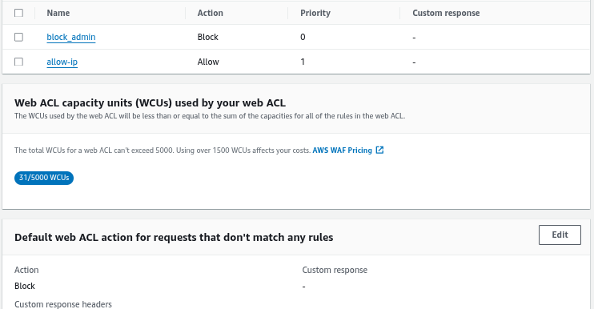

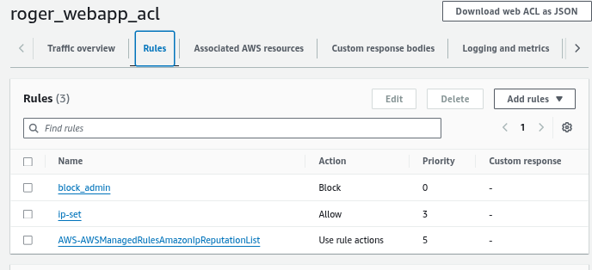

**\*\*\*\*\*\*\*\*\*\*\*\*\*\*\*\*\*\*\*\*\*\*\*\*\*\*\*\*\*\*\*\*\*\*\*\*\*\*\*\*\*\*\*activity notes\*\*\*\*\*\*\*\*\*\*\*\*\*\*\*\*\*\*\*\*\*\*\*\*\*\*\*\*\*\*\*\*\*\*\*\*\*\***

## WAF Access Control Lists with Application Load Balancers

### 

**WAF Access Control Lists with Application Load Balancers 1**

Overview 2

Prerequisites 2

Setup 2

Step 1: Create IP Set 2

Step 2: Create Web ACL 4

Add rules and rule groups 4

Set rule priority 4

Create Web ACL 4

Step 3: Verify setup 5

Step 4: Block the /admin path 5

Step 5: Add AWS managed rule 6

Step 6: Explore rules from AWS Marketplace 6

Step 7: Observability on Web ACL 6

Step 8: Teardown 7

### 

### 

### Overview

This is an activity that introduces you to AWS Web Application Firewall (WAF). We would explore some rules we can apply on the WAF to protect our application that is made accessible through a public application load balancer.

### Prerequisites

An existing VPC

An existing deployment that is **accessible through a public application load balancer**

### Setup

Fork the repository (<https://github.com/slim-sandbox/tf-ec2-alb>) into your Github account

Clone the repository from your Github account into your workstation

Set the necessary values for the region, VPC, and name in the Terraform code

Terraform apply

### Step 1: Create IP Set

Do a web search for your public IPv4 address, and create an IP set on AWS WAF.

Using CIDR notation, a subnet mask can help represent a range of IPv4 addresses. When the subnet mask is /32, it simply represents a single IPv4 address.

Details

Name: <name>-ipset

Region: (Region of application deployment)

IP addresses: (Public IPv4 address in CIDR format)

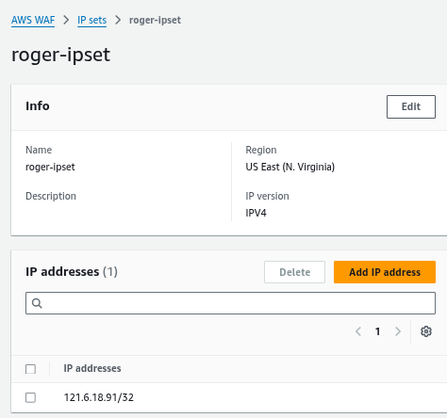

### Step 2: Create Web ACL

Details and associated resources

Fill as follows,

**Resource type:** Regional

**Name:** <name>-webapp-acl

**Associated AWS resources:** (rger-webapp-alb)

**Associate the Web ACL with the ALB:**

Go to the **AWS WAF & Shield Console**.

Select your Web ACL.

Click **Associated AWS resources**.

Click **Add AWS resources**.

Select your Application Load Balancer from the list.

Click **Add**.

### 

#### Add rules and rule groups

Just create your own rule for now.

**Rule type:** IP set; Type: Regular rule  
**Name:** allow-ip   
**IP set:** (Select your IP set)  
**Originating address:** Source IP address  
**Action:** Allow

#### Set rule priority

**Web ACL capacity units (WCUs)** - Notice the WCUs increase with each additional rule.



**Default action that don’t match any rule:** Block

#### Create Web ACL

Leave the rest of the configuration as default and create the web ACL  
**Verify the Configuration:**

Ensure traffic to your EC2 instance flows through the ALB.

Test the /admin path to confirm it is blocked.

### 

### Step 3: Verify setup

Visit the website from your workstation. It should be accessible still  
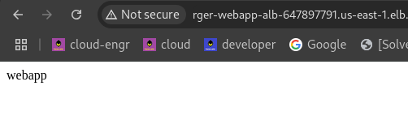

Visit the website from your mobile, with WiFi turned off. It should be blocked with a 403 Forbidden message

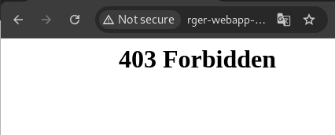

### Step 4: Block the /admin path

Create a self-managed rule that will block access to the /admin path.

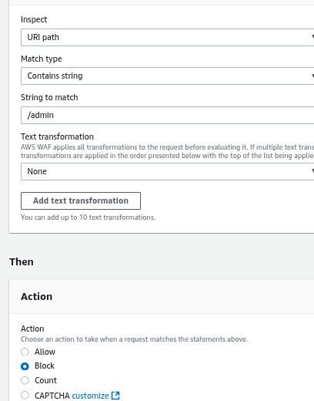

To validate the new rules in your browser, you would require to either clear the browser’s cache through the use of hard refresh, or use of Incognito mode.

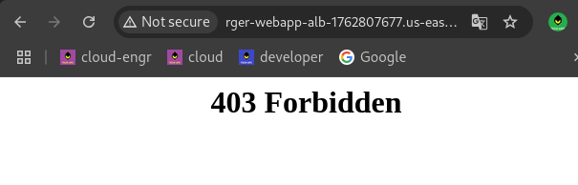

Question

Does the rule priority matter? Which rule is applied first?

Priority doesn’t matter.

Is the blocked path case sensitive? What can be done to ensure it is still blocked?  
Can set to lowercase, regex pattern, or statements in web_acl rule

### 

### Step 5: Add AWS managed rule

Add a managed rule that will block the addresses of bad actors as identified by Amazon threat intelligence.

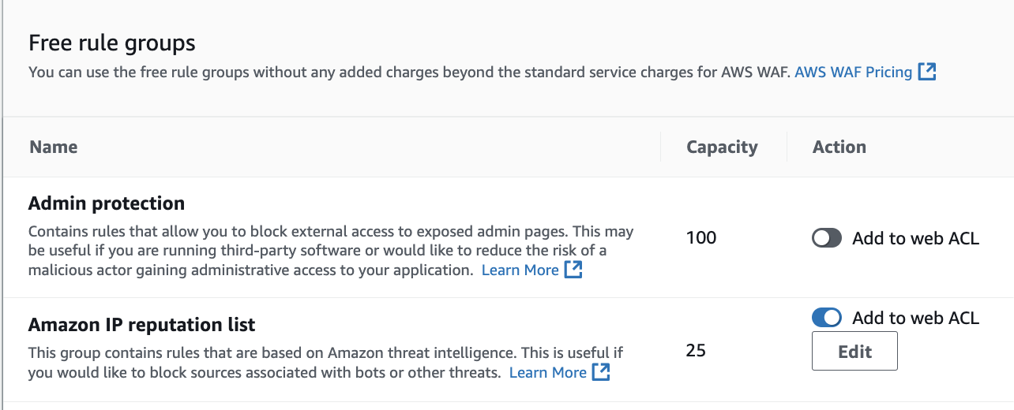

Have a read at the managed rule documentation to know what it does.



Question

Are there any overwrites, needed on the rule actions, to block the addresses that have been identified as actively engaging in malicious activities?

What should the rule priority be?

### 

From this exercise the WAF web ACL only works on alb-domains-to-the-webapp but still the public ip address where the web app is hosted is still accessible. Therefore,

1. hard-code the specific ip address + block all traffic setting in security group ingress,  
2. update DNS, point domain name to ALB's DNS instead of EC2 public IP

3. launch EC2 without public IP address, need NAT gw for egress while EC2 in pte subnet.  
Above 3 is the additional security to protect web_app access.

### Step 6: Explore rules from AWS Marketplace

Identify who are the third-party providers that provide rules for protection against OWASP Top 10

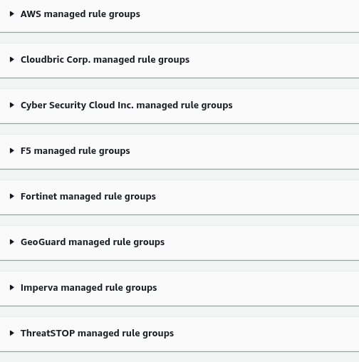

### Step 7: Observability on Web ACL

It might be surprising to see that it did not take much time to have web requests made:

by bots

from regions outside of Singapore

to reach the admin pages

### Step 8: Teardown

Check for assignment requirements before tearing down the created resources.

Destroy the WAF resources created via the console

Destroy the Web Application resources created via Terraform.

### Step 9: Questions

Would you want to block all bots? Why not?

### **Pros:**

**Security**: By blocking bots, you can reduce the risk of malicious activities such as DDoS attacks, scraping, and other automated threats.

**Performance**: Bots can consume resources and slow down your website. Blocking them can improve your site's performance.

**Data Integrity**: Preventing bots from accessing your site ensures that your analytics data remains accurate, reflecting genuine user interactions.

### **Cons:**

**Good Bots**: Not all bots are bad. Search engine crawlers, such as those from Google and Bing, help index your site and make it searchable. Blocking these can negatively impact your SEO.

**False Positives**: Some legitimate users or services might be mistaken for bots and get blocked, leading to a poor user experience.

**Maintenance**: Managing and maintaining bot rules can be time-consuming, as you'll need to constantly update and tweak settings to ensure the right balance.

### **Balanced Approach:**

Instead of blocking all bots, consider using a more nuanced approach:

**Rate Limiting**: Restrict the number of requests from a single IP address in a given time frame.

**CAPTCHA**: Implement CAPTCHA challenges to differentiate between humans and bots.

**Bot Management Solutions**: Use advanced bot management solutions that can identify and allow good bots while blocking malicious ones.